**1. Perform the following queries using DUAL:**

**a. Display the current DATE and TIME.**

SQL> select systimestamp from dual;

SYSTIMESTAMP

---------------------------------------------------------------------------

05-MAR-24 02.23.27.942000 PM +05:30

**b. Multiply 2 by 2.**

SQL> select 2*2 from dual;

       2*2

----------

         4

**c. Find the absolute value of -15.**

SQL> select abs(-15) from dual;

  ABS(-15)

----------

        15

**d. Calculate the square root of 5.**

SQL> select sqrt(5) from dual;

   SQRT(5)

----------

2.23606798

**e. Round off 15.19 to one decimal point.**

SQL> select round(15.19) from dual;

ROUND(15.19)

------------

          15

**f. Display the name " IVAN BAYROSS" in LOWERCASE.**

SQL> select lower('IVAN BAYROSS') from dual;

LOWER('IVANB

------------

ivan bayross

**g. Display the name " IVAN BAYROSS" in UPPERCASE.**

SQL> select upper('ivan bayross') from dual;

UPPER('IVANB

------------

IVAN BAYROSS

**h. Add 5 months to the present date and print the output.**

SQL> SELECT ADD_MONTHS(SYSDATE, 5) AS FUTURE_DATE FROM dual;

FUTURE_DA

---------

05-AUG-24

**i. Display the number of months between ‘02-JAN-01' and '02-JUL-01'**

SQL> SELECT MONTHS_BETWEEN(DATE '2002-07-01', DATE '2002-01-01') AS MONTH_DIFF FROM dual;

MONTH_DIFF

----------

         6

**j. Print the system date in the particular format ‘DD/MMIYYYY'**

SQL> SELECT TO_CHAR(SYSDATE, 'DD/MM/YYYY') AS FORMATTED_DATE FROM dual;

FORMATTED_

----------

05/03/2024

2.

CREATE TABLE EMP_NEW(

EMPNO NUMBER(4) PRIMARY KEY CHECK (EMPNO BETWEEN 7000 AND 8000),

ENAME VARCHAR(10),

JOB CHAR(10),

MGR NUMBER(4),

HIREDATE DATE,

SAL NUMBER(10,2),

COMM NUMBER(10,2) DEFAULT 0 CHECK (COMM < 1500),

DEPT_NAME VARCHAR(50),

CONSTRAINT CHECK_JOB CHECK ((JOB = 'salesman' AND COMM IS NOT NULL) OR (JOB <> 'salesman' AND COMM IS NULL)),

FOREIGN KEY(MGR) REFERENCES EMP_NEW(EMPNO)

);

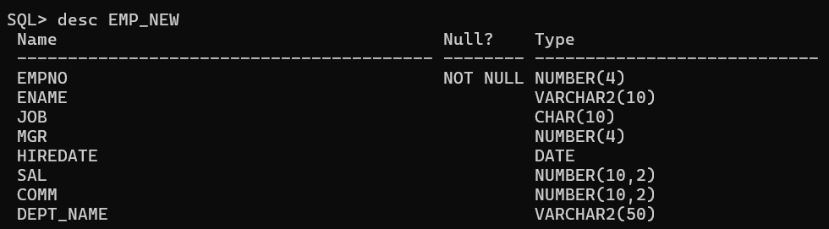

INSERT into EMP_NEW VALUES(7839, 'King','President',7839,'17-nov-81', 5000,NULL,'Accounting');

INSERT into EMP_NEW VALUES(7566, 'Jones','Manager', 7839,'2-apr-81', 2975,NULL,'Research');

INSERT into EMP_NEW VALUES(7698, 'Blake','Manager', 7839,'1-may-81', 2850,NULL, 'Sales');

INSERT into EMP_NEW VALUES(7782, 'Clark','Manager', 7839,'9-jun-81', 2450 ,NULL,'Accounting');

INSERT into EMP_NEW VALUES(7788, 'Scott','Analyst', 7566,'9-dec-82', 3000,NULL,'Research');

INSERT into EMP_NEW VALUES(7902, 'Ford','Analyst', 7566, '4-dec-81', 3000,NULL,'Research');

INSERT into EMP_NEW VALUES(7499, 'Allen','Salesman', 7698,'20-feb-81', 1600, 300,'Sales');

INSERT into EMP_NEW VALUES(7521, 'Ward','Salesman', 7698,'22-feb-81', 1250, 500,'Sales');

INSERT into EMP_NEW VALUES(7654, 'Martin','Salesman', 7698,'28-sep-81', 1250 ,1400,'Sales');

INSERT into EMP_NEW VALUES(7844, 'Turner','Salesman', 7698,'8-sep-81', 1500 ,0,'Sales');

INSERT into EMP_NEW VALUES(7876, 'Adams','Clerk',7788,'12-jan-83', 1100,NULL,'Research');

INSERT into EMP_NEW VALUES(7934, 'Miller','Clerk', 7782, '23-jan-82', 1300,NULL,'Accounting');

INSERT into EMP_NEW VALUES(7369,'Smith','Clerk',7902,'17-dec-80',800,NULL,'Research');

1. SELECT ENAME FROM EMP_NEW WHERE ENAME LIKE '_i%';

2. SELECT ENAME FROM EMP_NEW WHERE JOB <> 'Manager' ;

3. SELECT MAX(SAL) AS Maximum , MIN(SAL) AS Minimum , SUM(SAL) AS Total , AVG(SAL) AS Average FROM EMP_NEW ;

4. SELECT JOB , MAX(SAL) AS Maximum , MIN(SAL) AS Minimum , SUM(SAL) AS Total , AVG(SAL) AS Average FROM EMP_NEW GROUP BY JOB ;

5. SELECT COUNT(*) AS "Number_of_Managers" FROM EMP_NEW WHERE JOB = 'Manager';

6. SELECT ENAME FROM EMP_NEW WHERE HIREDATE > '01-jan-1980' ;

7. SELECT MAX(SAL) AS "Max Salary" FROM EMP_NEW WHERE JOB = 'Salesman';